Borwick and Priest Hutton

Community Emergency Plan

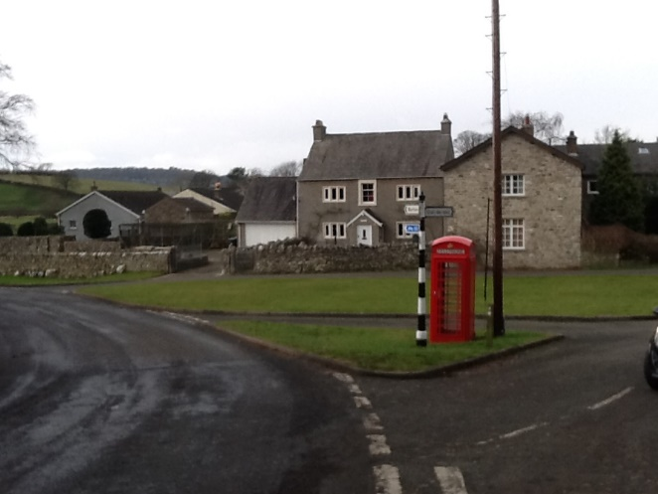

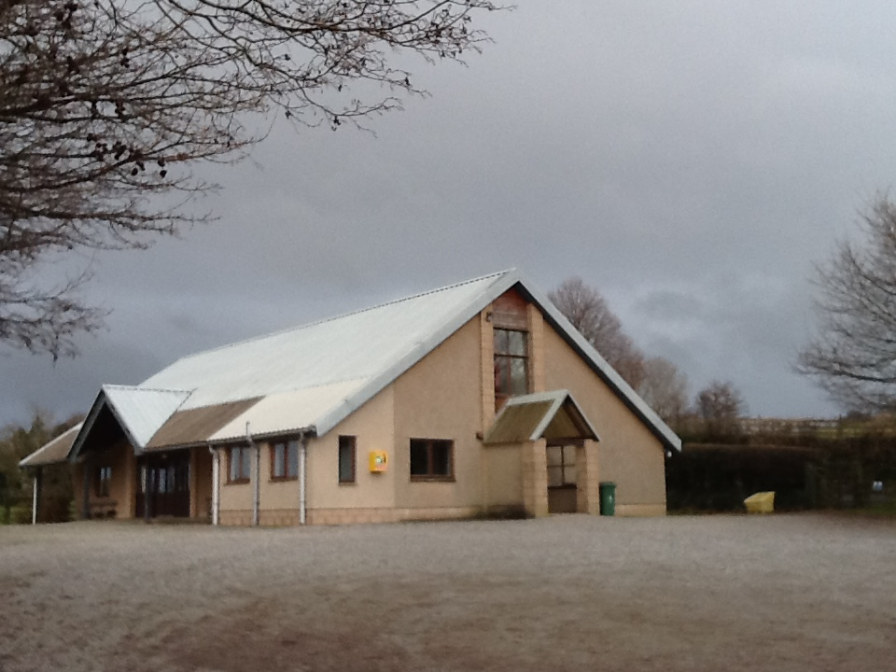

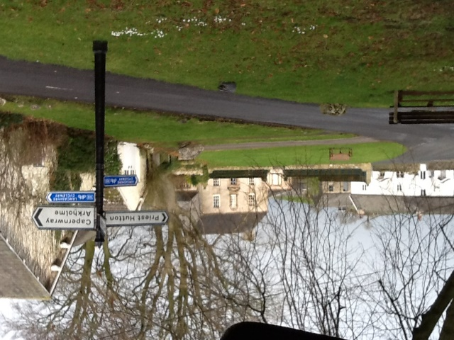

Local Version May 2019

Contents
Plan ownership 3
Distribution record 4
Record of amendments 5
Section 1: Information 6
1.1 Area Covered by the Plan 6
1.2 Priest Hutton Profile 7
1.3 Borwick Profile 8
1.4 Visitors to the Area 9
Section 2: Intention 10
2.1 Aim of the Community Emergency Plan 10
2.2 Structure of the Community Emergency Scheme 10
Section 3: Method 11
3.1 Activating the Plan 11
3.2 Primary Emergency Contacts 11
3.3 Local Emergency Contacts 12
3.4 Resources 12
3.5 Role of Agencies in an Emergency 13
3.6 Ministers of Religion and Faith Leaders 15
3.7 Community Preparation 15
3.8 Flooding Response 16
3.9 Severe Weather Response 17
3.10 Fire and Rescue Response 19
3.11 Medical Emergency Response 19
3.12 Utility Failure – Electricity 21
3.13 Utility Failure - Water Supply 21
3.14 Other Incidents 21
Section 4: Administration and Activation 22
4.1 Emergency Plan 22
Section 5: Communication Methods 22
5.1 Local Communication 22
5.2 Public Information 23
5.3 Who to contact in an emergency 24
Appendix A - Primary Emergency Contacts 28
Appendix B - Local Emergency Contact List 29
Appendix C - Organisations Contact List 30

Plan ownership

Community | Borwick and Priest Hutton Parishes
Plan owner | Borwick and Priest Hutton War Memorial Hall (Eric Rooney)
Version | Version 0.1
Date | May 2019

At the minimum, the plan owner and Primary Emergency Contacts should keep a hard copy of this document available for use if the plan is activated.
The plan owner is responsible for ensuring the plan remains up to date.

Plan Owner:

Eric Rooney
Committee Member
Borwick and Priest Hutton Memorial Hall
Sunnyside, Priest Hutton LA6 1JP
01524 781 468
07825 931 995

Distribution record

01 - Name | Borwick Parish | Date Sent
Contact | David Smith | 07/05/19 | Chairman
Address | 1 The Green, Borwick
Tel Contact | 07739 838401

02 - Name | Priest Hutton Parish | Date Sent
Contact | Martin Shuttleworth | 07/05/19 | Chairman
Address | Beech House, Priest Hutton
Tel Contact | 3330062327

03 - Name | Borwick and Priest Hutton Memorial Hall | Date Sent
Contact | Ken Dunn | 07/05/19 | Chairman
Address | Lorien, Priest Hutton
Tel Contact | 01524 781384

04 - Name | Borwick and Priest Hutton First Responders | Date Sent
Contact | Eric Rooney | 07/05/19 | Team coordinator
Address | Sunnyside, Priest Hutton
Tel Contact | 01524 781468

05 - Name | Website | Date Sent
Contact | Simon Smith | 07/05/19 | Webmaster
Address | Gibson House, Priest Hutton
Tel Contact

06 - Name | Newsletter / Communications | Date Sent
Contact | Jean Johns  Hilary Rooney | 07/05/19 | Communication Contacts List holder
Address | Megs Yeat Cottage, P Hutton  Sunnyside, Priest Hutton
Tel Contact | 01524 781887/ 01524 781468

07 - Name | Borwick Hall Outdoor Education Centre | Date Sent
Contact | Sam Litten | 07/05/19 | Centre Head
Address | Borwick Hall
Tel Contact | Day 01524 732508 Night 07543 844010

08 - Name | Lancaster City Council | Date Sent
Contact | Mark Bartlett | 07/05/19 | Civil Contingencies Officer
Address | Morecambe Town Hall
Tel Contact | 01524 582680

The Civil Contingencies Officer at Lancaster City Council will ensure that electronic versions of this plan are circulated appropriately within the council and forwarded to:

Lancashire Constabulary
Lancashire Fire and Rescue Service
North West Ambulance Service
Lancashire County Council Emergency Planning
Environment Agency
Any other appropriate responder agency

Record of amendments

Ensure amendments are recorded here. Please notify the Civil Contingencies Officer at Lancaster City Council immediately of any changes.

Annual review
Date | Reviewed by | Signature
V1 | Mark Bartlett | 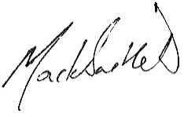

VERSION CONTROL AND AMENDMENT RECORD
No. | Date | Status | Amendments

Section 1: Information

This plan covers the parishes of Borwick and Priest Hutton

1.1 Area Covered by the Plan

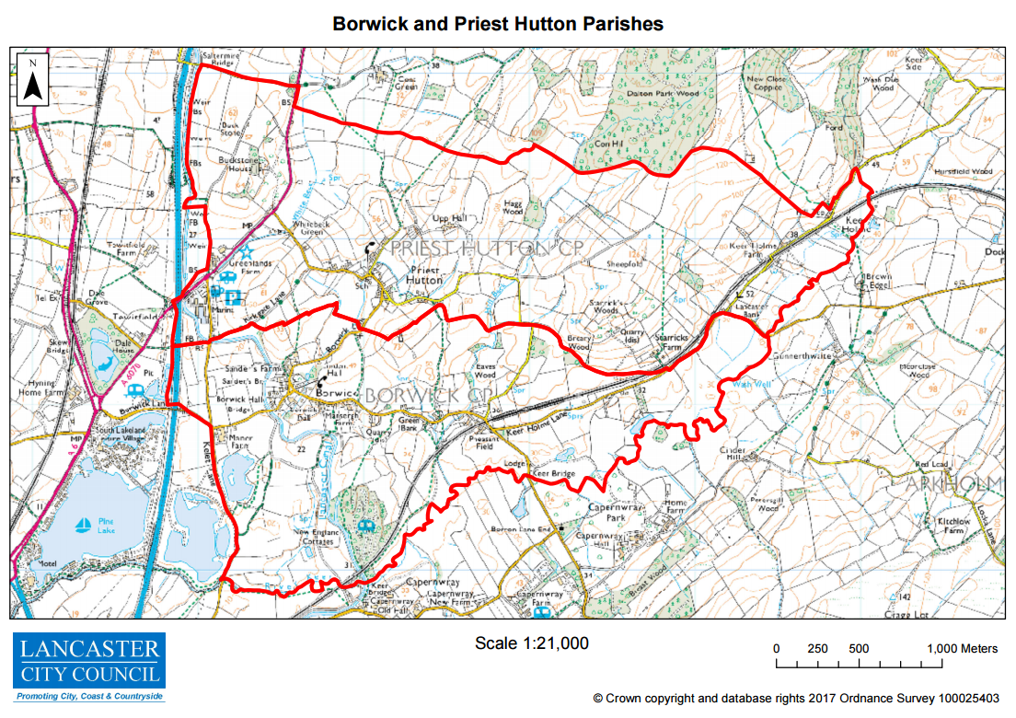

1.2 Priest Hutton Profile

Priest Hutton is a village and civil parish in Lancashire, England. It is located 5 kilometres (3.1 mi) north east of Carnforth, in the City of Lancaster, close to the boundary with Cumbria. In the 2001 census Priest Hutton had a population of 177, increasing to 185 at the 2011 Census.

The village, situated off the A6070, is in a rural area and has few facilities of its own. The village school closed in 1978, and the nearest school and post office are at Burton-in-Kendal, north of the county boundary. Other facilities, such as Borwick and Priest Hutton Memorial Hall, and St Mary's Church, are shared with the neighbouring village of Borwick, south of Priest Hutton. Priest Hutton has no parish council, instead there is a parish meeting at the Memorial Hall.

In the south west corner of the parish, at Tewitfield, there is a marina on the Lancaster Canal, currently the northern terminus of the canal's navigable section.

Flooding is known to occur when the becks are running high after heavy rain, and the run-off from the Upp Hall area flows downhill. There was some flooding during Storm Desmond and electricity supplies were interrupted for 3 days.

Population 185 (2011)
Civil parish Priest Hutton
District Lancaster
Shire County Lancashire
Region North West
Post town CARNFORTH
Postcode district LA6
Dialling code 01524
Police Lancashire
Fire Lancashire
Ambulance North West
EU Parliament North West England
UK Parliament Morecambe and Lunesdale
OS grid reference SD530737

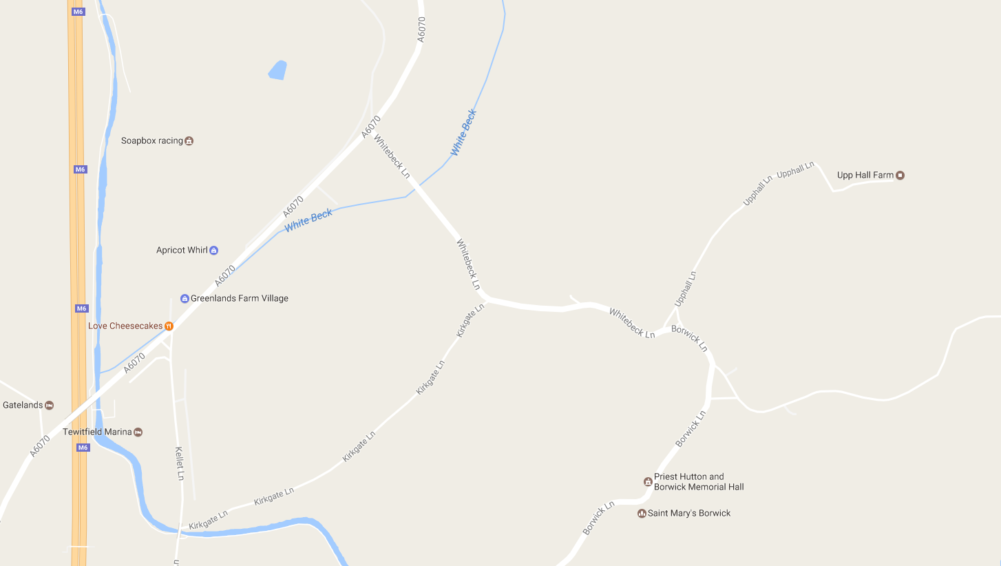

1.3 Borwick Profile

Borwick is a village and civil parish in the City of Lancaster district of Lancashire, England, about 8 miles north of Lancaster, on the Lancaster Canal. It is situated just south of the border with Cumbria. The parish of Borwick had a population of 210 recorded in the 2001 census, decreasing to 181 at the 2011 Census. Facilities, such as Borwick and Priest Hutton Memorial Hall, and St Mary's Church, are shared with the neighbouring village of Priest Hutton, north of Borwick. Borwick has no parish council, instead there is a parish meeting held at Borwick Hall, the Lancashire County Council outdoor education centre.

Flooding is known to occur when the beck which runs through the village overflows. It runs between properties and into the grounds of Borwick Hall. Regular cleaning is required to ensure good flow, although during Storm Desmond in 2015 levels were raised and electricity supplies were disrupted.

Population 181 (2011)
Civil parish Borwick
District Lancaster
Shire County Lancashire
Region North West
Post town CARNFORTH
Postcode district LA6
Dialling code 01524
Police Lancashire
Fire Lancashire
Ambulance North West
EU Parliament North West England
UK Parliament Morecambe and Lunesdale
OS grid reference SD525730

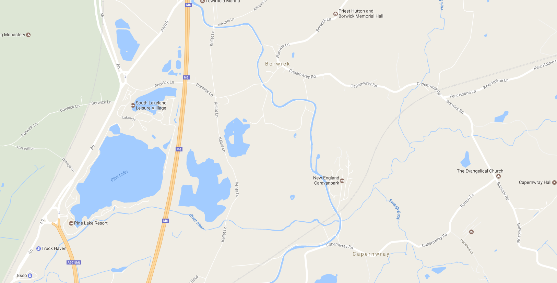

1.4 Visitors to the Area

Visitors to the area who need to be considered alongside residents include children and young people at Borwick Hall, a residential outdoor centre based at Borwick Hall.

Additionally there are a number of holiday parks, with a combination of short term visitors and residents who use the properties for the majority of the months of the year. These facilities include:

Gatelands, LA6 1JH
South Lakeland Leisure Village, LA6 1BH
Pine Lake Resort, LA6 1JZ, (technically just outside the parish boundary)

The area includes a number of businesses and attractions around the Tewitfield area which have large daily volumes of visitors.

The Longlands Hotel, LA6 1JH
Greenlands Farm Village, LA6 1JH
Tewitfield Marina complex, LA6 1JH
Clearwater Fisheries, LA6 1JU

Contact details
Further information on these organisations, and confidential telephone numbers where appropriate, is held by the Primary Emergency Contacts (Appendix A).

Section 2: Intention

2.1 Aim of the Community Emergency Plan

The aim of this plan is to provide a single source of local information to improve community resilience and provide an effective initial response in an emergency situation.
The specific emergency situations covered by the plan include:
- Flooding
- Predicted severe or extreme weather (high winds etc.)
- Any other widespread incident
- Medical emergency
- Fire
- Significant utility failure (electricity/water)

2.2 Structure of the Community Emergency Scheme

The Civil Contingencies Service of Lancaster City Council has prepared the template of this scheme and assisted the Borwick and Priest Hutton community representatives to complete it. The scheme is completely voluntary and there is no statutory duty to participate but the community saw it as a positive step to take in improving their resilience after the widespread flooding and power cuts in December 2015.
The scheme provides a framework for listing contact details, responsibilities and information about resources. It is intended to be of real help in taking action at the onset of an emergency and also assist in dealing with day-to-day problems that can arise in rural communities.

Section 3: Method

3.1 Activating the Plan

The Plan will be activated through a communication from one of the Primary Emergency Contacts listed in part 3.2 (full details at Appendix A).

This will take place in response to an observed emergency or information received of the imminent likelihood of an emergency event.

Local Emergency Contacts (confidential lists of whom are held by the Primary Emergency Contacts only; see Appendix B) will be alerted to gather at the Memorial (Village) Hall, or other site as the situation demands, where:

- Briefing on the nature and severity of the emergency will be shared.
- Other agencies will be alerted as necessary.
- Necessary procedures for relief of the emergency will be put into action through the group and through others recruited to the tasks from the community contact list held by the Primary Emergency Contacts.
·

3.2 Primary Emergency Contacts

The Emergency Plan lists people living in different areas of the community who have good local knowledge and contacts and who will be well placed to initiate action at short notice. These are our Primary Emergency Contacts.

Examples of the tasks the Primary Emergency Contacts might undertake:

Prior to an emergency | During an emergency
Disseminate vital information about scheme to the rest of the community | Activate the plan
Exercise the plan to ensure it is functional | Recruit volunteers and allocate tasks
 | Maintain a log including information on those who may need special help
 | Operate the local emergency centre
 | Collect, record and disseminate information

Primary Emergency Contacts

(Please see contact details in Appendix A at the end of this document for telephone numbers)

Eric Rooney | Village Hall Committee/ First Responder
Keith Brady | Priest Hutton Parish/ Village Hall Committee
Dave Scott | Borwick Parish/ Village Hall Committee
Claire Helme | Emergency Response Group/ Village Hall Committee/ Parish Clerk

3.3 Local Emergency Contacts

In the development of this plan, members of the community with particular skills or equipment have been contacted and have agreed to support the community should an emergency arise. A full list and contact details will be held by the Primary Emergency Contacts, and also with the version of the plan held securely at the village hall. Their details will not form part of the published version of the plan.

A public version of the plan will be made available to all residents along with communication to encourage them to be aware of personal preparation, the plan, and its activation process.

3.4 Resources

Borwick and Priest Hutton War Memorial Hall OS Map Ref SDSD529734

Borwick Lane, Borwick, Carnforth. LA6 1JP

The Hall can be used as an emergency muster point if such facilities are required for any incident that causes this plan to be activated. An emergency generator can be connected (stored adjacent to the Hall). The building can be used as a community centre. Heating, lighting and catering facilities would be available in the event of an emergency response.

Details of key holders are held by Primary Emergency Contacts.

There is also limited communal space in St Mary’s Church immediately opposite.

Emergency equipment

There is a programme within the community of encouraging residents to invest in personal emergency equipment, particularly torches, lamps, radios, phone chargers, and also first aid kits.

An emergency box has also been prepared and is kept at the Hall and maintained by the Primary Emergency Contacts. The box contains:

- A copy of the community emergency plan, including Appendix B
- Maps of the area
- Appropriate stationery and materials to provide a logbook and simple message forms.
- A list of residents
- Wind-up radio
- Wind-up torch/lamp

An inventory has been made of suitable sources of ‘community-held’ equipment and members of the community who have agreed to assist in an emergency. This is held by the Primary Emergency Contacts.

3.5 Role of Agencies in an Emergency

Police - the Lancashire Constabulary is responsible for the coordination of all other agencies at the scene of any emergency incident. The police also investigate any possible criminal aspects of any incident.

The Lancashire Fire & Rescue Service is responsible for fire-fighting and rescue. They are comprehensively equipped with search and rescue equipment, including specialist equipment for rescue from collapsed buildings. They also have access to high volume pumping equipment and may be asked to assist in flooding incidents. Many crew members are trained to be first responders at medical emergencies too.

The North West Ambulance Service is responsible for providing First Aid to casualties at the scene of any emergency incident and transport of casualties to hospital. At any multi-agency incident the Ambulance Service is the ‘gateway’ organisation to the wider National Health Service meaning that, in an emergency, other agencies wishing to access any health organisation will initially do so through the Ambulance Service.

Borwick and Priest Hutton operate a Community First Responders scheme which is controlled by the North West Ambulance Service. The scheme operates in association with neighbouring groups in Burton, Holme and Yealand.

HM Coastguard, whilst primarily coordinating the response to coastal and off-shore incidents, also has access to resources that can assist in inland emergencies, particularly flooding.

The University Hospitals of Morecambe Bay NHS Trust has an emergency plan for the treatment of casualties at local hospitals and further afield. This includes the deployment of a Hospital Mobile Emergency Team into the community.

The Environment Agency has a particular responsibility for flood forecasting and warning and the identification of flood risk areas. It is also involved in managing water pollution emergencies.

Lancaster City Council supports the emergency services at an incident by the provision of a Duty Emergency Incident Officer, Evacuation Rest Centres, waste clearing operations, and environmental protection advice along with engineering and building control services.

Lancashire County Council also has an Emergency Planning Duty Officer and also provides countywide services such as Education and Adult & Children’s (Social) Services.

Voluntary Organisations offering their various skills to the communities of Lancashire in times of emergency include:

- St. John Ambulance
- British Red Cross
- WRVS
- Salvation Army
- RSPCA
- Raynet (Radio Amateurs)
- Faith Groups
- Mountain Rescue Teams

These voluntary organisations are coordinated in Lancashire by the County Council Emergency Planning Service and the initial contact point for any of the above organisations must be the County Emergency Planning Duty Officer, who can be contacted by the Lancaster City Council Duty Emergency Incident Officer or any of the ‘blue light’ services.

Agencies supporting these organisations include:

- Electricity North West - provide specialised assistance concerning electricity supplies; to continue to supply electricity; to liaise with other organisations for the provision of emergency supplies and the disconnection of cables that constitute a danger to life and property.

- United Utilities - deal with the maintenance of water supplies and sewage disposal arrangements, repairs to water mains and the availability of emergency water supplies in an incident. Additionally they hold a priority services register for those who might need a little extra help. https://www.unitedutilities.com/help-and-support/priority-services/

3.6 Ministers of Religion and Faith Leaders

Ministers of religion are familiar with the problems of care within the community. They are experienced in leadership, organisation and counselling the sick.

The current minister is based in Warton and looks after St Mary’s, Borwick and the two parishes. Through the Lancashire Resilience Forum it is possible to access a much wider multi-faith community if there are particular needs during or after an incident.

3.7 Community Preparation

Residents are encouraged to keep themselves informed and be aware of weather conditions that may result in flooding or other disruption. Sources of this information include:

Met Office – severe weather warning forecasts
Environment Agency – Flood Alert notifications. These include automated messages to landlines, mobile telephones, tweets and e-mails for residents and business registered for the Flood Warning Area scheme.
Local radio – broadcasts of Environment Agency flood watches and weather warnings.

Residents in outlying areas are encouraged to maintain emergency packs and in periods of good weather should check that equipment is working correctly, batteries charged and essential supplies restocked. Where flood defence equipment is kept in readiness or has been installed it should be maintained including oiling/greasing of mechanisms. Whilst sandbags are only of limited use, if they are held they should be checked to confirm they are safe and dry. Drainage channels should be checked, and if necessary cleaned.

Priest Hutton Flood Action Group

Priest Hutton Flood Action Group was formed to benefit individuals in the Priest Hutton Parish who are or who may be affected by flooding.
It seeks to:

- work alone or with others to reduce the risk of flooding and to minimise its material damage and its social, environmental, health and economic effects
- campaign among parishioners and relevant organisations to promote better understanding of local flooding and to ensure due priority for Priest Hutton’s identified needs at City Council and County Council level
- carry out any other activities that the Committee considers appropriate and relevant to the elimination or mitigation of flooding risk in the administrative Parish of Priest Hutton

A study is to be undertaken by the LCC’s consultants with the assistance and part-funding of Priest Hutton Parish. This is to determine the causes of flooding throughout the village and assess what needs to be done to ameliorate it. Lancashire County Council officers have committed to implement the study’s findings.
Whilst the outcome of the study is awaited, committee members are mitigating the current flood risk by keeping roadside grids clear, clearing the beck and monitoring the effects of rainfall.

3.8 Flooding Response

Where any flood alert/warning or severe weather warning is received that is expected to affect the Borwick and Priest Hutton community, the Duty Emergency Incident Officer at Lancaster City Council will speak to a Primary Emergency Contact and discuss any assistance that may be needed.

Flood Watch

The Environment Agency will issue Flood Alerts. Residents can register to receive these Flood Watch messages, which are also passed automatically to the Emergency Services and local authorities.
Only limited telemetry is available on the rivers and becks in the area and the Environment Agency cannot give further information beyond a basic Flood Watch alert.

River level monitoring stations
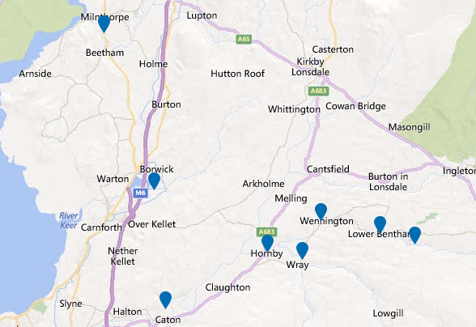

It is known, however, that many streams rise and fall rapidly in heavy rainfall situations. It is important that the Primary Emergency Contacts mobilise local residents who can, without putting themselves in danger, monitor the becks. If water levels are felt to be rising rapidly or there is other evidence of flooding upstream (changing water colour, trees or other objects being swept down,) this information should be passed back to the Primary Emergency Contacts who will in turn alert the Environment Agency.

If there are local indications that the becks are likely to flood homes and businesses it is important to act quickly.

Environment Agency recommended actions:

- Move cars, pets, food, valuables and important documents to safety
- Fit flood protection equipment (air brick covers, door barriers etc.)
- Turn off gas, electricity and water supplies if safe to do so
- Be prepared to evacuate your home or premises
- Protect yourself, your family and help others
- Act on your flood plan

3.9 Severe Weather Response

Apart from the risk of flooding the most likely scenario to affect this area is a warning of heavy snow or one of high winds. At times of low risk of snow or storms the community will endeavour to maintain properties in a good state of repair with particular attention to the maintenance of chimney stacks, general pointing of brickwork on buildings and walls, roof tiles and roofing felt and any bracketed equipment such as aerials and dishes. In addition, the condition of trees near to buildings, or anywhere else where they might cause disruption or injury if they fell, should be monitored and where necessary remedial action taken. The Primary Emergency Contacts will check the availability of sand and salt in appropriate areas and ensure levels in grit boxes are maintained.

Three types of weather warning are issued by the Met Office:

Advisory of severe or extreme weather
Advisories are issued by 11:00 daily as routine, and indicate the confidence level of expected severe or extreme weather. Early Warnings and Flash Warnings supersede Advisories when confidence levels are 60% or greater.

Early Warning of severe or extreme weather
These are issued when the Met Office has a 60% confidence or greater of severe or extreme weather.

Flash Warnings of severe or extreme weather
These are issued when the Met Office has 80% or greater confidence of severe weather in the next few hours. If warnings have been issued the NW Region page of the Met Office website will have more detailed information.

Weather warnings guide
The Met Office warns the public and emergency services of severe or hazardous weather which has the potential to cause damage, widespread disruption and/or danger to life through our National Severe Weather Warning Service. This includes warnings about rain, snow, wind, fog and ice.
These warnings are given a colour depending on a combination of both the likelihood of the event happening and the impact the conditions may have.

The basic messages associated with each of the colours are:
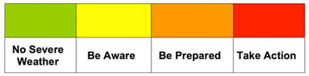

The basic message associated with each warning level is:
Likelihood
High | - You may need to take action as we are expecting ...  - There will be ...
Medium | - We should be prepared for ...  - There is likely to be ...
Low | - Be aware of the potential/possibility ...  - There is the small chance of ...
Very Low | - Be aware that there is a very small risk of ...

What the colours mean
- Yellow: Be aware. Severe weather is possible over the next few days and could affect you. Yellow means that you should plan ahead thinking about possible travel delays, or the disruption of your day-to-day activities. The Met Office is monitoring the developing weather situation and Yellow means keep an eye on the latest forecast and be aware that the weather may change or worsen, leading to disruption of your plans in the next few days.

- Amber: Be prepared. There is an increased likelihood of bad weather affecting you, which could potentially disrupt your plans and possibly cause travel delays, road and rail closures, interruption to power and the potential risk to life and property. Amber means you need to be prepared to change your plans and protect you, your family and community from the impacts of the severe weather based on the forecast from the Met Office.

- Red: Take action. Extreme weather is expected. Red means you should take action now to keep yourself and others safe from the impact of the weather. Widespread damage, travel and power disruption and risk to life is likely. You must avoid dangerous areas and follow the advice of the emergency services and local authorities.
Severe weather warnings are available to you in a number of ways, meaning you can always access the latest information wherever you are. This includes on radio, TV, the Met Office website, social media, smart phone apps, RSS and via email alerts.
You can help by passing these warnings on to family and friends, or by sharing them on Facebook, Twitter and other social media with you friends and followers.

3.10 Fire and Rescue Response

- Lancashire Fire and Rescue Service will respond to all calls to fires or other emergencies.
- Residents, on discovering a fire, should call the Fire Service via 999, leave the premises, and not return until given the all-clear.
- The Fire Service will respond to requests from residents regarding Home Fire Safety Checks, fitting smoke detectors and advice on fire plans for every occupant.

3.11 Medical Emergency Response

The North West Ambulance Service is responsible for providing First Aid to casualties at the scene of any emergency incident and transport of casualties to hospital. At any multi-agency incident the Ambulance Service is the ‘gateway’ organisation to the wider National Health Service meaning that, in an emergency, other agencies wishing to access any health organisation will initially do so through the Ambulance service.

For certain medical emergencies, the North West Ambulance Service will mobilise the Community First Responder network, who are equipped with emergency life-saving equipment, eg oxygen and defibrillators, which can potentially be deployed before an ambulance or rapid response vehicle arrives.

Community Public Access Defibrillators

With the support of local residents, the Borwick and Priest Hutton Community First Responder Group has purchased and installed Public Access Defibrillators. They are situated at 3 locations, and can be accessed following dialling 999.

Borwick and Priest Hutton Memorial Hall (Point A)
The Green, Priest Hutton (Point B)
Borwick Hall Outdoor Education Centre (Point C)

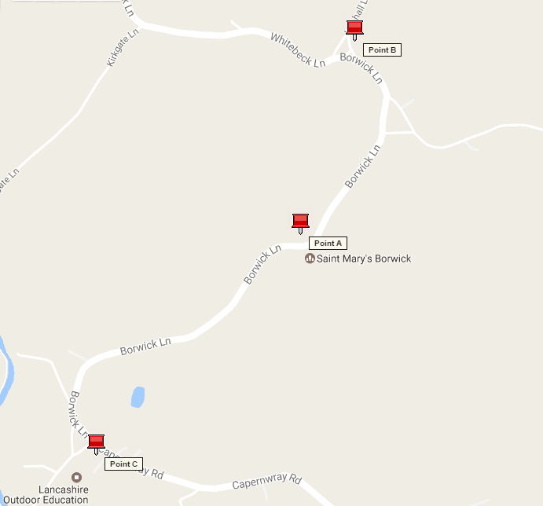

3.12 Utility Failure – Electricity

In the event of electricity supply failure residents should ring the Electricity North West control centre in the normal way to report the problem. This may require mobile use if electricity and VOIP phone, which are widespread, is down. This allows the control centre to assess the nature and scale of the breakdown. Reporting and updates on mobile phones are available via the Electricity North West website. https://www.enwl.co.uk/power-cuts/live-power-cut-information/

If it becomes apparent to any of the Primary Emergency Contacts that the power cut is widespread or likely to become protracted they should contact the rest of the group to consider what action is necessary to support the community, particularly any vulnerable members and whether to activate the emergency plan. The City Council Duty Emergency Incident Officer (DEIO) should also be contacted, via the Council’s Emergency Call Centre.
If it is necessary to contact the Electricity North West Emergency Control Centre Manager for further information the DEIO will do this on behalf of the community.
An emergency generator is available to provide power to the Borwick and Priest Hutton Memorial Hall, and its use will be activated through this plan.

3.13 Utility Failure - Water Supply

In the event of a water supply failure residents should ring the United Utilities control centre in the normal way to report the problem. This may require mobile use if electricity and VOIP phones, which are widespread, are down. This allows the Control Centre to assess the nature and scale of the supply breakdown. Reporting and updates on mobile phones are available via the United Utilities website https://www.unitedutilities.com/emergencies/

If it becomes apparent to any of the Primary Emergency Contacts that the water supply problems are widespread or likely to become protracted they should contact the rest of the group to consider what action is necessary to support the community, particularly any vulnerable members and whether to activate he emergency plan. The City Council Duty Emergency Incident Officer (DEIO) should also be contacted, via the Council’s Emergency Call Centre.
If it is necessary to contact the United Utilities Emergency Control Centre Manager for further information the DEIO will do this on behalf of the community. The DEIO has the necessary information and contacts to organise alternative water supplies, for drinking and for sanitation, in an emergency.

3.14 Other Incidents

A plan of this nature can never cover all situations. In the event of any other type of emergency occurring the community will seek assistance through the usual channels and if necessary use the Primary Emergency Contacts to coordinate the local response and to call on any of the organisations outlined in this plan.

Section 4: Administration and Activation

4.1 Emergency Plan

This Plan has been produced by the community in association with the Civil Contingencies Officer at Lancaster City Council. It has been quality assured by Lancashire County Council Emergency Planning Service and the Environment Agency. The Plan Owner and other Community Contacts are responsible for keeping the plan up to date. The plan will be reviewed at least annually or after any activation.

The plan is available for any member of the community to read and the planners welcome any observations on how it may be improved.

Activation of the plan will be the responsibility of the Primary Emergency Contacts who will assess the developing situation and arrange for appropriate and proportionate communication and action.

Section 5: Communication Methods

5.1 Local Communication

The area is relatively small geographically with the community clustered in the villages, and word of mouth communication can easily be organised during an actual emergency where normal communication methods are disrupted. Outlying areas would be contacted using volunteers with suitable vehicles.

In the preparation phase, and if the electricity supply is not affected, the area covered by the plan has an excellent high speed fibre broadband network which most residents are connected to (B4RN). This was a previous community project, and the network routing equipment is at the Borwick and Priest Hutton Memorial Hall. In advance of a predicted emergency, good communication between residents is possible and there is an email list of residents specifically for use as part of this emergency plan. Residents also have high speed access to public information and advice over the internet.

In the event of a power failure the emergency generator at the hall would be deployed, providing continued communication from there, recognising however that individual homes may not have power, and therefore this digital communication route may be disrupted.

If the mobile phone network is still active, then texts and voice will be used over that network, particularly between the Primary Emergency Contacts and Local Emergency Contacts.

If the mobile network is down, 2-way radios are stored at the Memorial (Village) Hall.

Activating the communications will be the responsibility of the Primary Emergency Contacts.

5.2 Public Information

The local radio and television will carry severe weather warnings, advice to the public and emergency telephone numbers. In the event of a power cut, a wind-up, battery-operated or car radio should be used to monitor broadcasts.

The radio stations also have up-to-date information on their websites about emergency situations

Station | Frequency
 | FM | Website
BBC Radio Lancashire  (In an emergency situation Radio Lancashire stops its regular transmissions and moves to its public information role known as “Connecting in a Crisis” ) | 103.9, 95.5, 104.5 and DAB  Digital Radio | www.bbc.co.uk/lancashire
Heart (North Lancashire) | 96.9, 105.4 | https://www.heart.co.uk/northlancs/
Smooth (Lake District) | 100.1,  100.8 | https://www.smoothradio.com/lakes/radio/

5.3 Who to contact in an emergency

Contact details are attached in Appendix C

Organisation | Service | Contact for
Emergency Services
Police  Lancashire Constabulary | Police Service  Coordinator of all responder services at any incident | Emergency response for the protection of life.
Lancashire Fire and Rescue | Emergency response for the rescue of people trapped by fire, wreckage or debris, extinguishing fires and dealing with hazardous substances, inland water rescue | Emergency response for situations described.
North West Ambulance Service | Emergency medical treatment | Emergency medical treatment
Bowland & Pennine Mountain  Rescue Team  (Call out via Police) | Carry out land search and rescue operations on behalf of the police force | Emergency land search and rescue
Royal National Lifeboat Institute | Carry out sea and water rescue operations | Emergency sea and water rescue. Also help in inland flooding.
Local Authorities
Lancaster City Council  Lancashire County Council | To support the emergency services during an emergency and then lead the recovery process in returning the community back to normality following an incident. | Issues relating to:  Waste management  Housing  Environmental health  Emergency Planning & Business Continuity
 | To support the emergency services in the emergency phase and the recovery process following an incident. | Issues relating to:  Education  Highways  Social services  Trading standards

Utilities
Gas  (National Grid Transco PLC) | Maintenance of satisfactory gas supply, ensure rapid restoration of an interrupted gas supply including repair to gas mains. The primary function of Transco in an incident will be the safe control of gas supplies. | Problems in gas supply
Electricity North West | To provide specialised assistance concerning electricity supplies; to continue to supply electricity; to liaise with other organisations for the provision of emergency supplies. Disconnection of cables that constitute a danger to life and property. | Problems in electricity supply
Water  (United Utilities) | Maintenance of water supplies and sewage disposal arrangements, repairs to water mains and the availability of emergency water supplies during an incident. | Problems in water supply
Telephones  (British Telecom) | Maintenance and operation of National Telecommunications systems. Provision of increased facilities to meet emergency requirements. | Problems local telephone network supply
British Waterways (if applicable) | Staff trained in flood relief. Provision of pumping, excavating and dredging equipment; marine craft and transport on navigable waterways. | Problems with main waterways
Governmental
Departments

DEFRA | Governmental Department of the Environment, Food and Rural Affairs. | Problems which concern farmers and the countryside, the environment, and the rural economy.
Environment Agency | Specialist advice and supervision of measures to combat pollution of rivers, streams and inland waterways or contamination of supplies. | Chemical or oil spillages,  Pollution incidents,  Flooding information.

Voluntary Organisations | In Lancashire the Voluntary organisations are coordinated and activated by the Lancashire County Council Emergency Planning Service. Any activation of voluntary organisations in an emergency must be via the County Council.
Women’s Royal Voluntary Service | The WRVS have volunteers trained in emergency service provisions such as reception centres, emergency feeding and other welfare services. | Provide staff to administer reception and/ or assist at reception centres to:  - Prepare light refreshments  - Assist school catering staff with preparation of full emergency feeding arrangements  - Assist with the registration of survivors/ evacuees  - Distribution of emergency clothing  - Assist with distressed friends and relatives  - Assist with care and comforting survivors/ evacuees  - Comfort for individual family groups  - Assist with feeding of emergency service personnel.
St John Ambulance | Provision of trained first aiders, ambulances and additional medical supplies. | - Reinforcement to medical teams at the scene and/ or Casualty Clearing Stations.  - Welfare services at hospitals and assistance with distressed friends and relatives.  - Assistance at reception and/ or reception centres.
British Red Cross | British Red Cross volunteers are trained to provide a range of services and skills in any major incident. | - Immediate welfare and comforting for casualties, survivors, evacuees, friends and relatives at the scene, hospitals or reception and/or reception centres  - Provide transport and escort for the disabled  - Medical loan equipment  - First aid in centres  - Tracing and message service
Salvation Army | The Salvation Army is prepared to act in a supportive role in a major incident. | Assist at the scene including provision of spiritual assistance  - Assist with the care of friends and relatives, particularly care of the bereaved.  - Provide emergency services catering support  - Provide overnight/ short stay shelter and assist other welfare agencies
Royal Society for the Prevention of Cruelty to Animals (RSPCA) | Animal welfare | Assist with care of animals in the aftermath of a major incident
RAYNET – Radio Amateurs’ Network | Temporary communications – radio and telephony | Assist with all aspects of communications in the aftermath of a major incident
The Samaritans | Long-term listening/support service which is available 24 hours a day, every day of the year | Provision of support by volunteers experienced in supporting those who have gone through deep emotional stress

Appendix A - Primary Emergency Contacts

Primary Emergency Contacts

Eric Rooney | Village Hall Committee /First Responder | 01524 781468  07825 931995
Keith Brady | Priest Hutton Parish | 01524 782053  07780 585362
Dave Scott | Borwick Parish | 01524 732735  07778 680763
Claire Helme | Emergency Response Group | 01524 732818  07845 186958

Appendix B - Local Emergency Contact List

This appendix is confidential and held by the Primary Emergency Contacts.

Appendix C - Organisations Contact List

Organisations Contact List
Organisation | Address | Tel No: 1 | Tel No:2
Lancashire Constabulary | Hutton, Preston  PR4 5SB | 999 – Emergency/ 101  (Non-emergency)
Lancashire Fire and  Rescue | North West Fire Control, Warrington | 999 or 01925 460841 | 01524 411590  (Morecambe Fire  Station)
North West Ambulance  Service | Broughton, Preston | 999 or 01772 862666
Cave and Fell Rescue  Teams  (Call out via Police) | Via Lancashire Constabulary | 999
Environment Agency | Lutra House, Preston | 01772 714110 | 0800 807 060 (incident  hotline)
DEFRA |  | 08459 335577 | 08459 881188  (Floodline)
Met Office |  | 0870 900 0100
Medical
Lancaster Royal Infirmary | Lancaster | 01524 65944
Ash Trees Surgery | Carnforth | 01524 720000
Park View Surgery | Milnthorpe | 01539 715555
Same Day Health Centre, Morecambe | Morecambe | 111
NHS Medical advice (nonemergency) |  | 111
Councils
Lancaster City Council | Lancaster & Morecambe | Switchboard  01524 582000 | 24hr Emergency Call  Centre  01524 67099
Lancashire County Council (Emergency Planning  Service) | Preston | 08450 530 000
Utilities
Gas  (National Grid Transco) |  | Service calls  0870 606 4750 | Emergencies  0800 111 999
Electricity  (Electricity North West) |  | Loss of electricity  0800 195 4141
Water  (United Utilities) |  | Drinking water and waste water 0845 746 2200
British Telecom (Telephone lines) |  | 0800 800 151

